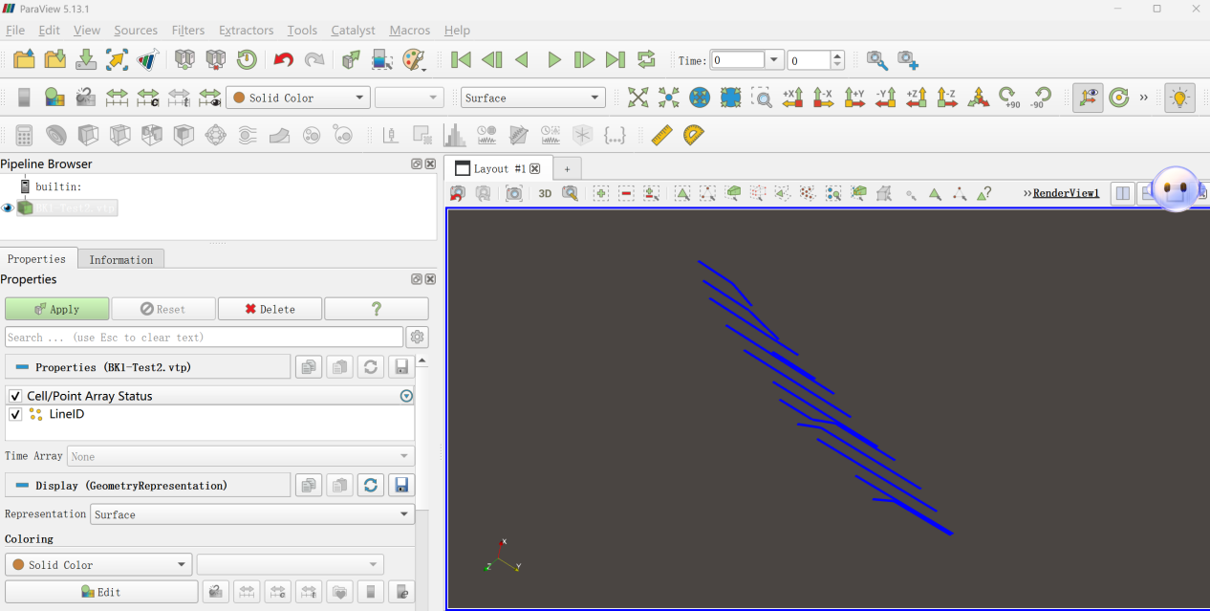
Figure 1 Visualization of Line Data

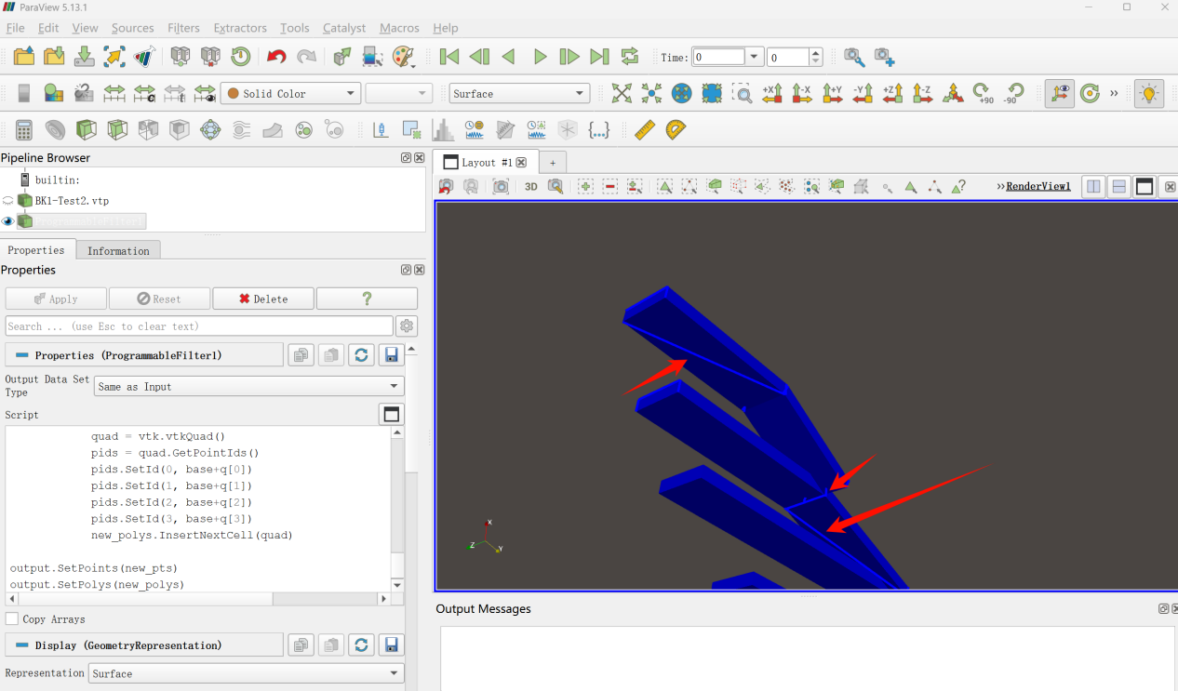
Figure 2 My Visualization Result (red indicates abnormal lines that should not appear)

